Cyber Kill chain:
The lock-heed martin proposed the cyber-kill chain.
There are 7-steps in the cyber kill chain and is very important for the both red-teamers and as well as the blue teamers.
It starts from:
Recon
Weaponization
Delivery
Exploitation
Installation
Commands & control
Actions.

Reconnaissance:
It is the first step of the attack where the attacker spends too much time here to collect the information about the target.
It can perform the OSINT which can also lie in under reconnaissance to collect the data about the target.

The phishing I,e Social engineering which can also lie in this category.

Email harvesting is also very useful.
Following tools are used for this purpose.

Like the email-harvester, this is a very powerful tools for harvesting the email as well as user name , ip address and URL.
Hunter.io: this is a specialized email harvesting tools and can creates a link or associated with the domains.

OSINT-Framework:
This open-source framework can be used to collect tools based on various categories.

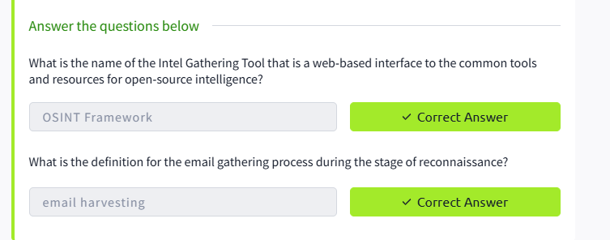

Weaponizations:
In this stage the malware is developed or purchased from the dark web. And embedded in the macros and VBA (basic visual for videos) i.e.,

Malware: the malicious software developed to disturb, takes controls the victim computer
Exploit: the piece of program or code that can take advantages to vulnerabilities to gain access.
Payload: is malicious code that a attacker run on the effected system.

Delivery:
Phishing email: in this technique we used the spear-phishing techniques to deliver our payload because we have collected the information before in our reconnaince step.
USB-dropping: in this technique the attacker the drops the infected USB at the public places or send it to the target company through mailing.

Water-holing: This is very creative technique in which the attacker compromised the web site frequently visited by the target group of people and the attacker redirect them to that compromised website and perform its objectives.

Exploitation:
In these techniques the attacker used the:
- The victims trigger the exploit by opening the email attachment or clicking on a malicious link.
- Using a zero-day exploit.
- Exploit software, hardware or even human vulnerabilities.
- An attacker triggers the exploit for server-based vulnerabilities.

Installations:
After the exploitation i.e., installing the backdoor to gain the initial access
But the attacker needs a persistent backdoor to it perform the installation even after the he loss initial access or the system is patched, he has the full control of the computer.
And also used the web shell for this purpose
The attacker used a lethal technique in which the use the time-stomping technique to modify the files’ timestamps, including the modify, access, create and change times.
The Timestomping technique lets an attacker modify the file's timestamps, including the modify, access, create and change times

- nstalling a backdoor on the victim's machine. For example, the attacker can use Meterpreter to install a backdoor on the victim's machine. Meterpreter is a Metasploit Framework payload that gives an interactive shell from which an attacker can interact with the victim's machine remotely and execute the malicious code.
- Creating or modifying Windows services. This technique is known as T1543.003 on MITRE ATT&CK (MITRE ATT&CK® is a knowledge base of adversary tactics and techniques based on real-world scenarios). An attacker can create or modify the Windows services to execute the malicious scripts or payloads regularly as a part of the persistence. An attacker can use the tools like sc.exe (sc.exe lets you Create, Start, Stop, Query, or Delete any Windows Service) and Reg to modify service configurations. The attacker can also masquerade the malicious payload by using a service name that is known to be related to the Operating System or legitimate software.

Command & Control:

